 |  | 

Sao Tome and Principe

GRANT – SAO TOME AND PRINCIPE - GEF 4494

Integrated Ecosystem Approach to Biodiversity Mainstreaming and Conservation in the Buffer Zones of the Obo and Principe Natural Parks

GEF Terminal Evaluation Report Summary

Map of project areas

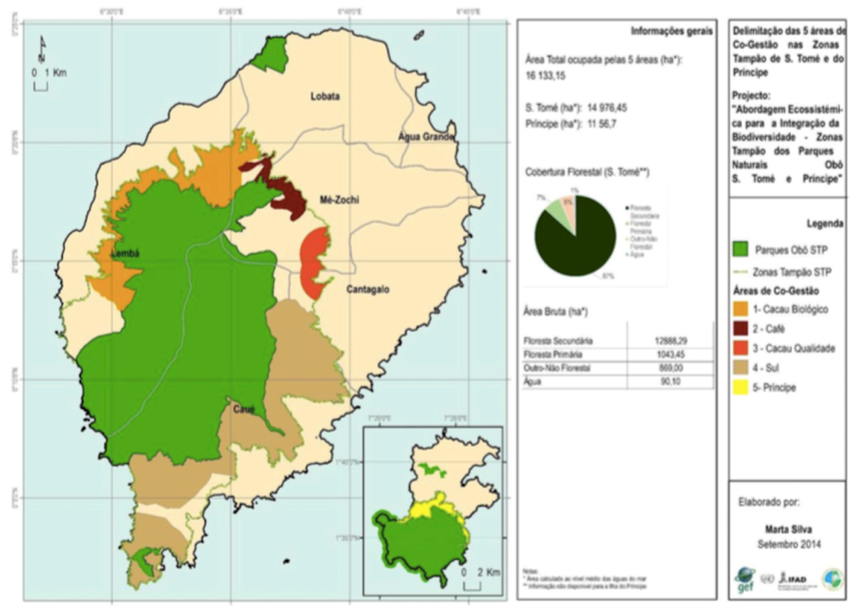

The project at a glance
Country | Sao Tome and Principe
Project Name | Integrated Ecosystem Approach to Biodiversity Mainstreaming and Conservation in the Buffer Zones of the Obo and Principe Natural Parks
Key Dates
IFAD Approval | Signing | Effectiveness | Mid-Term Review | Original Completion | Actual Completion
 |  |  | 28/10 – 8/11/2014 | 06/12/2015 | 06/06/2016
Original Grant Closing | Actual Grant Closing
06/06/2016 | 06/12/2016
Project Financing
GEF grant | Million USD | 2,42 | % disbursed | 71,7%
Government | Million USD | 0.29 | % disbursed | 1%
Actual Costs and Financing (USD ‘000)
Component |  |  | GEF grant |  |  |  |  | Government |  |  |  | Beneficiaries |  |  |  |  | Total
 |  |  | Allocated |  | Disb. | % |  | Alloc. | Disb. |  | % |  | Alloc. |  | Disb. | % |  | Alloc. |  | Disb. | %
Institutional support for biodiversity mainstreaming |  |  | 227 |  | 101 | 44% |  | 55 | - |  | 0% |  | 30 |  | - | - |  | 312 |  | 101 | 32%
Integrated ecosystem management for biodiversity conservation in the buffer zone of Obo National Park |  |  | 1816 |  | 1231 | 68% |  | 174 | - |  | 0% |  | 45 |  | - | - |  | 2035 |  | 1231 | 60%
Monitoring and Evaluation |  |  | 207 |  | 179 | 86% |  | - | - |  | - |  | 25 |  | - | - |  | 232 |  | 179 | 77%
Project management |  |  | 168 |  | 220 | 131% |  | 61 | 3 |  | 4,9% |  | 0 |  | - | - |  | 229 |  | 223 | 98%
Total |  |  | 2418 |  | 1730 | 72% |  | 290 | 3 |  | 1% |  | 100 |  | - | - |  | 2808 |  | 1733 | 62%
Number of Beneficiaries
 | Total |  |  | Direct |  |  | Indirect |  |  | Women |  |  |  | Other
Target | n.r. |  |  | n.r. |  |  | n.d. |  |  | n.d. |  |  |  | n.d.
Reached | 6 275 |  |  | 1 255 |  |  | n.d. |  |  | n.d. |  |  |  | n.d.
Project Objective
Rehabilitate degraded ecosystems to provide ecosystem services and a habitat for endemic species of flora and fauna of global importance.
Country Partners
Executing Agency |  | Ministry of Agriculture and Rural Development (MADR)

Project overview
- The project "Integrated Ecosystem Approach to Biodiversity Mainstreaming and Conservation in the Buffer Zones of the Obo and Principe Natural Parks", financed by a grant from the Global Environment Facility (GEF) of USD 2.418 million, was formulated with the objective of reducing biodiversity loss and ecosystem degradation by promoting the development of traditional (coffee and cocoa) and non-traditional (livestock, food crops) value chains, ensuring a sustainable use of forests and promoting eco-tourism development, particularly in the north-western areas of São Tomé.
- The Project has been designed, for a period of 3 years, as an additional financing and an integrated component of the Participatory Smallholder and Artisanal Fisheries Development Program (PAPAFPA). It targeted, in connection with the activities of PAPAFPA, 44 communities, having a direct impact on natural resources exploitation in the buffer zone of the Natural Parks of São Tomé and Príncipe. The Project came into effect on December 6, 2012 and following a 6 month extension ended June 6, 2016.
- The overall objective of the Project is to rehabilitate degraded ecosystems to provide ecosystem services and habitat for endemic species of flora and fauna of global importance. "This objective is broken down into:
- Environmental objective, which is to promote the integration of biodiversity and integrated ecosystem management in the buffer zones of the Obo Natural Parks of São Tomé and Príncipe ; and
- Development objective of increasing revenue streams through biodiversity-friendly production and sustainable activities
- In terms of impact, the Project aimed at the sustainable management of 7,200 ha of biodiversity-rich ecosystems: (i) about 5,000 ha of rain forest in the buffer zones; (ii) 2,000 ha of marine ecosystems; and (iii) 200 ha of coastal mangroves.
- The Project is structured around 3 components: (i) Institutional support for the integration of biodiversity in the sectoral policies of the country; (ii) Integrated ecosystem management and biodiversity conservation in buffer zones of protected areas; and (iii) Monitoring and Evaluation.
Project relevance
- Project activities, as identified in the Project Design Report (PDR), are relevant as they respond to the priorities of preserving natural resources and biodiversity in a country where natural parks are threatened by the growth of agricultural areas. The numerous delays and methodological weaknesses of the Project's intervention (management of partnerships, institutional support, monitoring of non-functional achievements, etc.) have in most cases led to moderately relevant results. The project’s results did not achieve the desired objectives, which were ambitious for the institutional context of São Tomé and Príncipe. The main shortcomings are related to ownership (institutions, management committees), replicability and sustainability (micro-projects (MP), advisory support to beneficiaries) of the project's achievements and the production of management tools that are not relevant to cope with identified issues and to put in place structured actions on a large scale. Globally, the relevance of the Project can be considered as moderately satisfactory (4/6).
Project Costs and Financing
- The total estimated cost of the Project was $ 2.8 million, including: (i) a grant of $ 2.42 million from the GEF; (ii) a Government contribution valued at USD 290,000; and (iii) a beneficiary contribution valued at US $ 102,000.
- The overall disbursement, all financings combined, amounts to USD 1.736 million, i.e. an overall financial implementation rate of 61.8%, which is considered as moderately insufficient. The disbursement rate of the GEF grant reached 71.7% as of August 31, 2016. The disbursement rate by category is respectively: 58.6% for category I "Workshops and training"; 73.4% for category II "Technical assistance"; 72.9% for the "Equipment" category and 78.6% for the "Salaries, Operations and Maintenance" category. The Government's contribution (duties and taxes) represented only 1.0% of the planned amount (very insufficient) and that of the beneficiaries was not valued. Expenditures supposed to be supported by the Government have almost all been imputed to the GEF grant.
Project efficiency
- The project financial management has been inefficient, as shown by the large differences in the financial implementation rates of the technical components and the overall coordination of the Project. Coordination costs exceeded the forecasted costs by 30%, while the disbursement rates for the first two technical components were 44 and 68% respectively. The disbursement rate of the monitoring and evaluation component is 86%, but the M&E system did not produce data that could help to better pilot the Project and improve its performance.
- Despite a broad appeal to private providers, we cannot say that this brought great technical efficiency in carrying out activities. The level of completion and the quality of many achievements are not satisfactory. They are not replicable and therefore cannot bring the expected benefits. In addition, complementarity with the other IFAD projects (PAPAFPA/PAPAC) have not been fully exploited. The additional 6-month period allowed the completion of many activities that were still in the start-up phase at the date originally planned for the completion, but did not reinforce the achievements of the Project. This allowed to increase the disbursement rate, but the benefits of these expenses raise questions.
- The project’s technical and economic efficiency analysis of the Project could not be carried out because of the absence of analytical accounting and lack of economic data on the Project's achievements. Given all these considerations, the efficiency of the Project may be considered as unsatisfactory (2/6).
Project effectiveness
- Many outcome indicators of the logical framework were not quantified (7 out of 13) initially, nor during the project’s implementation. A results framework that would have made it possible to monitor more closely the effectiveness of the Project has not been put in place. Few quantified indicators have been fully achieved and the quality of the products is rarely of the expected level. Some of the Project's products were also prerequisites for other activities (co-management plans leading to the development and implementation of micro-projects). Given the very ambitious objectives and the significant delays that have characterized the implementation of the activities, some strategically important products are not in line with what was expected (co-management plans, among others) and therefore cannot really serve as a relevant basis for the development of structuring activities for the preservation of environment and biodiversity. In addition, no exit strategy has been prepared, which may limit the scope of the initiatives developed by the Project. Multiple documents were produced to inform the institutional dialogue on natural resources management in the Parks buffer zones, but only a few have been validated. The effectiveness of the Project can be considered as moderately unsatisfactory (3/6) but varies greatly depending on the activity.

Project impacts
- The project’s achievements are too recent (investments concentrated in the last 2 years of implementation) to be able to conclude to a real impact of the Project, in particular at the buffer zones communities level. Through the implementation of micro-project, the Project has directly contributed to increase the assets of about 1,060 households, but the real impact of these investments remains uncertain. Studies, awareness-raising and trainings have contributed to a change of vision of the institutional and field actors on their environment. However, the Project has not managed to develop (co)management plans as tools for participatory resources management geared towards biodiversity the conservation. Project impacts may be rated as moderately unsatisfactory (3/6).
Sustainability, Innovation and Scaling
- The Project did not have an exit strategy and therefore did not pay particular attention to the appropriate transfer of achievements to the concerned entities which should and could ensure the continuation and sustainability of the many processes and actions incurred. The capacity building of the beneficiaries has been too weak to initiate large-scale changes in natural resource exploitation practices. With the exception of the Directorate of Fisheries, the Project did not involve enough the institutions concerned, so they can fully appropriate the institutional changes envisaged. For all these reasons, the sustainability of Project results may be considered moderately unsatisfactory (3/6).
- The main innovation of the Project is the notion of co-management of natural resources in the buffer zones with the objective of increasing sources of income through biodiversity-friendly productions and sustainable activities. The co-management plans, the creation of a sustainable tourism platform, the implementation of managed marine areas are all innovations, but unfortunately they could not be carried out far enough to produce significant and replicable results. Large-scale replicability potential may be considered as moderately unsatisfactory (3/6).
Partners’ performance
- The performances of potential institutional partners could not be truly assessed, as in most cases their responsibility has not been formally engaged in activities falling within their particular area of ​​institutional competence. It must be noted, however, that the managers trained on the implementation of REDD + projects, as well as the Biodiversity Working Group, have not used the new knowledge acquired to develop initiatives that promote the objectives of the Project in their areas of intervention, particularly at the institutional level. The use of producer cooperatives (coffee and cocoa) for the implementation of micro-projects has led to interesting and relevant achievements, as they provided, inter alia, a structuring vision and technical expertise in the implementation of micro-projects. The skills and expertise provided by NGO partners and other private providers varied widely. The most competent could have been more involved and empowered as a strategic partner. Partner performance may be rated as moderately unsatisfactory (3/6).
Lessons learned
- The main lessons learned and experiences to remember and / or avoid for the future are:
- The participatory and inclusive approach developed by the project and its institutionalization have been highly appreciated by communities and can significantly improve sustainability.
- The environmental constraints and risks must be well analysed and taken into account concretely in the design of a project. In unstructured contexts, with difficulties in accessing effective proximity services, overly complex or overly ambitious projects should be avoided; limiting the number of implementing partners, ensuring the operationality of the activities are recommended.
- In an Micro-Project approach, the following must be taken into account: (i) easily reproducible MPs adapted to the environment; (ii) MPs of a technical level responding to the request of the beneficiaries; (iii) MPs promoting the learning and progressive mastery of technical and economic parameters of the activity, and (iv) an effective support system.
- The relevant national institutions should be fully involved from the beginning in activities aimed at improving the institutional framework. Projects need to build their capacity and institutions and projects can mutually benefit by working closely together.

Conclusions and recommendations
- To finalise the completion process, the Project will have to quickly carry out the impact study, allowing among other things to inform all the impact indicators of the logical framework and the stakeholder workshop, to share and evaluate in a participative way the achievements and effects achieved by the Project.
- Scaling up of training courses in sustainable agroforestry practices to reduce soil erosion, particularly through the dissemination of educational tools, should be considered within the framework of PAPAC or other government projects by involving the agriculture delegations and professional organizations.
- A study of the MPs financed by the Project, and possibly other MPs financed elsewhere, including the technical and economic aspects but also the conditions for their implementation (process of identification, selection, beneficiaries support, etc. ) should be engaged by PAPAC to establish actual operating accounts and draw lessons for future interventions.
TER Rating Matrix
Criterion | Rating
Project performance
- Relevance | 4
- Effectiveness | 3
- Efficiency | 2
- Sustainability | 3
Project impacts
- Households ‘incomes and assets | n/r
- Food security | n/a
- Human and social capital and empowerment | 4
- Agricultural productivity | 3
- Institutions and policies | 3
Overall impact of the project on rural poverty | 3
Additional evaluation criteria
- Gender equality and women’ s empowerment | 4
- Access to markets | 2
- Innovation | 4
- Potential for scaling-up | 3
- Environment and natural resources management | 4
- Adaptation to climate change | 3
- Targeting and outreach | 3
Partners performance
- IFAD’ s performance | 3
- Government performance | 3
Overall project performance | 5

Rating of components

Component | Rating
Component 1 : Institutional support for biodiversity mainstreaming | 4
Component 2 : Integrated ecosystem management for biodiversity conservation in the buffer zone of Obo National Park | 3
Component 3 : Monitoring and Evaluation | 2

